# Package algorithm

# Weilin Lu

1/18/2023

# Assignment 2: Divide and Conquer

## SUMMARY DESCRIPTION

For this project, I want to do a classification based on the destination of the package, and classify them according to the city, state and country where the package is located. So the first choice is not to seek their common ground. This part can be done using divide and conquer. We will talk about the international classification of the package according to the city classification of the package. I think this implements divide and conquer. At present, the time efficiency of this algorithm is O(n)

The format of the data in the given file is that the first digit is the package number, the second digit is the destination city, the third digit is the state of the destination, and the fourth digit is the destination country is US.The default state is MA. The default country is US. For the detail,please read the csv file.

## 1.2 PROJECTED I/O SPECIFIC EXAMPLE FROM PROJECTED COMPLETED PROJECT

Sample input as csv file:

1,TUS,AZ,US

2,LA,CA,US

3,BOS,MA,US

4,SF,CA,US

5PHX,AZ,US

6,Shanghai,SHN,CHN

7,LVA,NV,US

Example of output:

Package:1&5 are allocated into same state:AZ.

Package:2&4are allocated into same state:CA.

Package:3 is an in state package.

Package:1&2&3&4&6&7 are out state packages.

Package:6 is an international package.

## 1.3 REQUIREMENTS IMPLEMENTED IN THIS RELEASE

### 1.3.1 Your requirement title replaces this

The package should include package number,city,state and country

### 1.3.2 Your requirement title replaces this

The output should say the same things and the different things between the package

## 1.4 ILLUSTRATIVE OUTPUT

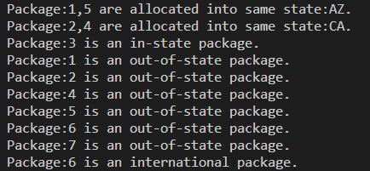

## 1.5 YOUR DIRECTORY AND README

All the functions defined are in the New divide and conquer.py, the program will read the file

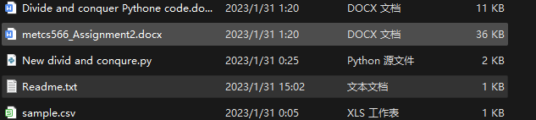

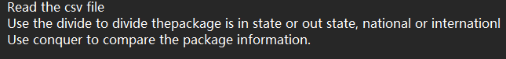

## 1.6 DIVIDE AND CONQUER IMPLEMENTED

### 1.6.1 Class model and Sequence Diagram

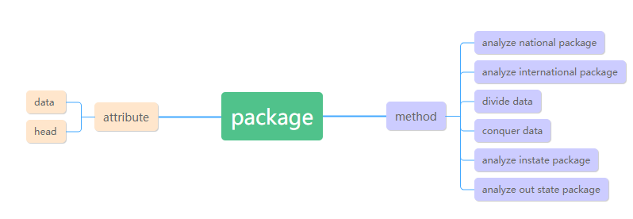

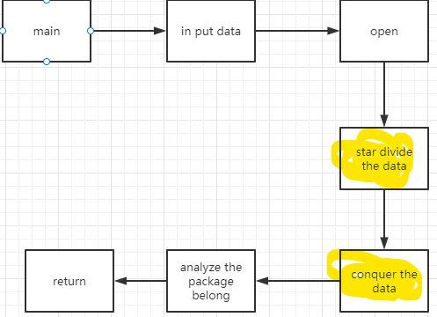

### 1.6.2 Divide & Conquer Algorithm Outline

1：input the csv file

2:Define the main function

3:Create the default state and country

4:Create the in/out state package and inter/national package lists

5:loop through the in/out state package and inter/national package

### 1.6.3 Code showing divide and conquer.

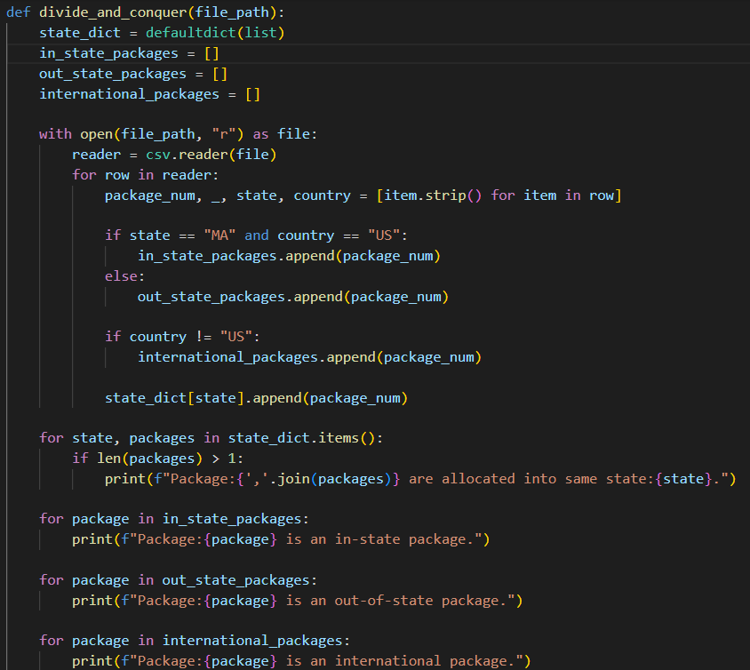

In my code, I first use divide to separate the packages into in state or our state packages. This is the first step. Then use conquer to find the similarities and differences of each package.

### 1.6.4 Efficiency

O(n):This is because the code performs a single pass through the file to read the data and populate the state and package mappings, and then a second pass to group the packages by state and country.

## 1.7 YOUR CODE

The python file and csv file will also come.

## 

## 1.8 Evaluation



## References (if used. Each of [1], [2], etc. should occur within the paper above.)

[1]

[2]

## Appendix 1 (if needed; should be referenced above, and will be read as-needed only)

## Appendix 2 (if needed; should be referenced above, and will be read as-needed only)